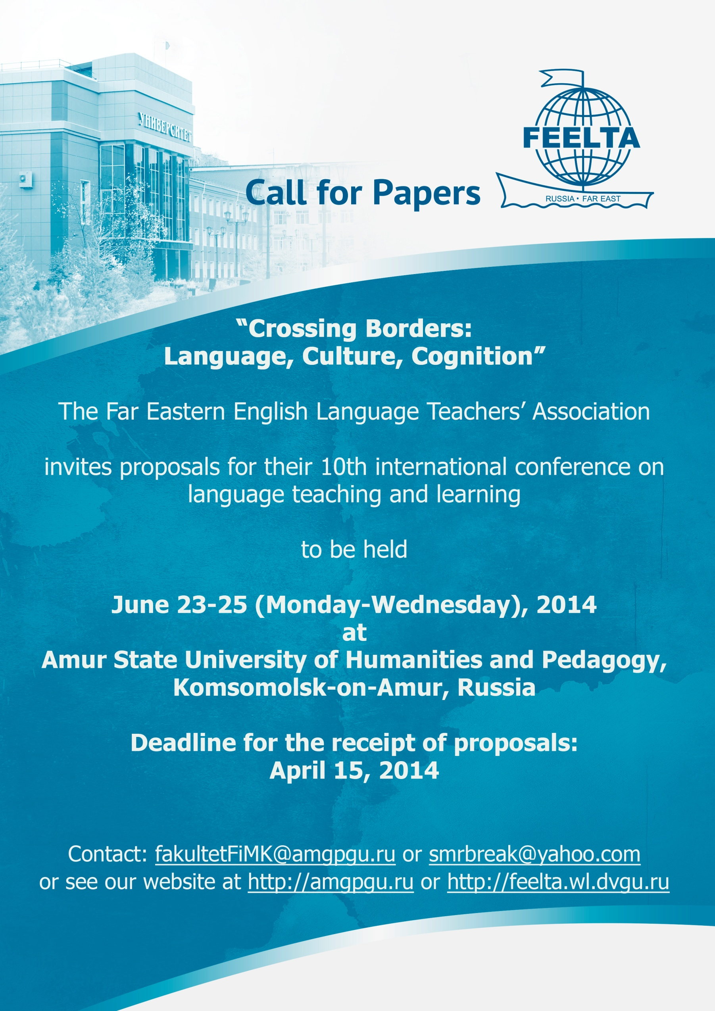
About FEELTA:

The Far Eastern English Language Teachers’ Association (FEELTA) is a professional organization founded in 1995. Its mission is to strengthen the teaching and learning of English in the Russian Far East, to promote the professional development of EFL teachers, to support networking with colleagues all over the world, and to give access to the latest EFL resources.
FEELTA headquarters is in the Far Eastern Federal University, Vladivostok. FEELTA has over 500 members in seven FEELTA posts in the Russian Far East: in Blagoveshchensk, Birobijan, Khabarovsk, Komsomolsk-on-Amur, Petropavlovsk-Kamchatsky, Ussuriysk, and Vladivostok. These posts provide ELT professionals with information and support within their geographical areas.
FEELTA’s premier event is the international conference, which is held every other year and attracts some 500 participants. It is a major event and EFL practitioners from even the remotest parts of the Russian Far East come to network and expand their knowledge. The location of the conference alternates between Vladivostok and one of the other FEELTA posts.
FEELTA is affiliated with NATE and IATEFL. It is part of the Pan-Asian Consortium of ELT associations (PAC).

About the Conference Theme:

Our conference concerns the concepts of connectedness and alienation, both cultural and linguistic, and the ways in which intercultural communication and teaching languages can help to overcome alienation and foster cultural connectedness.
The upcoming conference aims to encourage people from different backgrounds to unite in their commitment to teaching and studying EFL. The sessions will focus on furthering strategies for intercultural communication and linking language learning to culturally-congruent pedagogy.

Proposals:
Proposals are invited for conference presentations in the following categories:
short papers (25 minutes)
papers (50 minutes)
panels (110 minutes)
workshops (110 minutes)
poster sessions (displayed all day - presenters are expected to stand by their posters ready to explain and discuss them, for 60 mins.
Other sessions:
There will also be a Materials Share Fair and Publishers’ Displays.
We are planning to publish Proceedings and presenters are encouraged to submit their paper during the conference.

Topic Areas
- English in the Pacific Rim Countries
- Teaching Methods
- Cultural Issues
- English for Specific Purposes
- CALL, Technology and Multimedia
- Materials Writing
- Teaching Literature and Arts
- Teacher Development and Education
- Interpreting and Translating
- Linguistics
- Other Languages
- Global Issues in Language Education
- Area Studies

Materials to be submitted
- application form
- a title of up to 10 words
- an abstract of not more than 150 words, for peer review
- a summary of between 50 and 75 words, to be printed in the programme
- a self-introduction of not more than 25 words

Submissions may be made,
by email to: <facultetFiMK@amgpgu.ru>
by regular mail to Amur State University of Humanities and Pedagogy, International Department, Kirova St., 17/2, , 681000, RUSSIA

Equipment
Each room has a chalkboard and a presenter table. Check any other equipment required on the list below. Please help us by indicating equipment requirements now, rather than in the days before the conference.
- Audio-cassette player
- VHS video player (NTSC, PAL, and SECAM available)
- Smart Board
- Multi-media projector
- PC to connect to the data-projector

For further information
contact
- <facultetFiMK@amgpgu.ru>
- for international participants: Stephen Ryan: smrbreak@yahoo.com
- see AMGPGU website at http://amgpgu.ru or FEELTA website at http://feelta.wl.dvgu.ru/

RROPOSAL FORM
and 10th FEELTA International Conference
“Crossing Borders: Language, Culture, Cognition”
Komsomolsk-on-Amur, June 23-25,
Deadline for proposals: April 15, 2014

Details of Presenter
Title (Mr/Ms/Dr/Prof)
Family Name_____________________________First Name__________________
Address_______________________________________________________________________________________________________________________________
Telephone: home______________________________work____________________________
e-mail_____________________________________________________________
Institutional Affiliation________________________________________________
Details of Presentation
Title of Presentation (Maximum 10 words) ________________________________
___________________________________________________________________
Single/Joint presentation
Name, title, institution and email address of co-presenters___________________
___________________________________________________________________

Topic Area (Please tick)

- English in the Pacific Rim Countries
- Teaching Methods
- Cultural Issues
- English for Specific Purposes
- CALL, Technology and Multimedia
- Materials Writing
- Teaching Literature and Arts
- Teacher Development and Education
- Interpreting and Translating
- Linguistics
- Other Languages
- Global Issues in Language Education
- Area Studies

Presentation Requirements (Please tick)
Type of Presentation
- Short paper (25 min)
- Paper (50 min)
- Panel (110 min)
- Workshop (110 min)
- Poster

Equipment Required
- Overhead Projector
- Audio cassette recorder
- VHS + TV (please specify the system: PAL/SECAM/NTSC)
- Multimedia Data Projector
- PC to use with data projector
- Other (Please specify)

The presenters are required to submit:
1) this application form
2) a title of up to 10 words
3) an abstract of not more than 150 words, for peer review
4) a summary of between 50 and 75 words, to be printed in the programme
5) a self-introduction of not more than 25 words

PLEASE forward the completed form to <facultetFiMK@amgpgu.ru> by Apri 15, 2014.

For regular updates and an electronic version of this form, see: http://amgpgu.ru or http://feelta.wl.dvgu.ru/

